Calories Calculating Website

CIS201- Fundamentals of Web Design



Reem Alharbi

202022306

Calories Calculating Website

CIS201- Fundamentals of Web Design

Description of the Project

A simple and easy to use website that will calculate the calorie intake of some specific dishes that most of us eat daily. These dishes will be categorized into multiple sections Appetizers, main course, dessert and drinks. The calorie of each dish will be shown before adding it to the cart. After the user chooses some dishes, the user can move to the cart page that will show the total of the calorie intake.

Color Scheme



Color

Hexadecimal number

Used For

#0c3141

#ffffff

#f1c22f

#f21a06

#027f8d

Background, Text

Text

Button

Lines

Text, Text on Button



#9a9d9f

Text

Page Layout

## Home PageImage

## Dishes PageImage

## Cart PageImage

## About Me-Contact PageImage

page hierarchy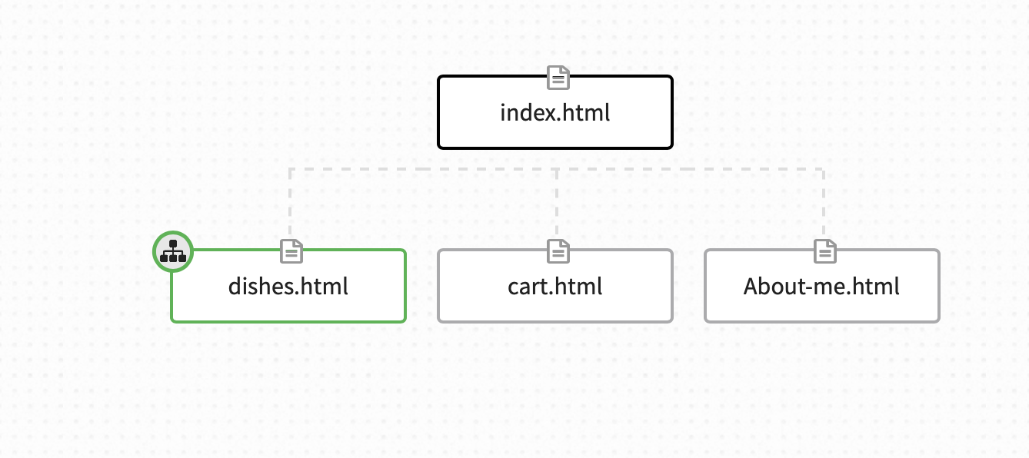

Index.html:

* Title: Home
* Home page - Welcome to Healthy Cart Calorie
* Content: Image and contains a "get started" button

Dishes.html:

* Title: Dishes
* Content: Product name, serving size, calorie count of the dish and using java a add to cart function and a drop down list function

Cart.html:

* Title: Cart
* Content: After adding the dishes from the dishes page, you can view the cart and the total amount of calories

About-me.html:

* Title: About Me-Contact
* Content: A paragraph about myself and why i created this website
* Contact- using email and phone number